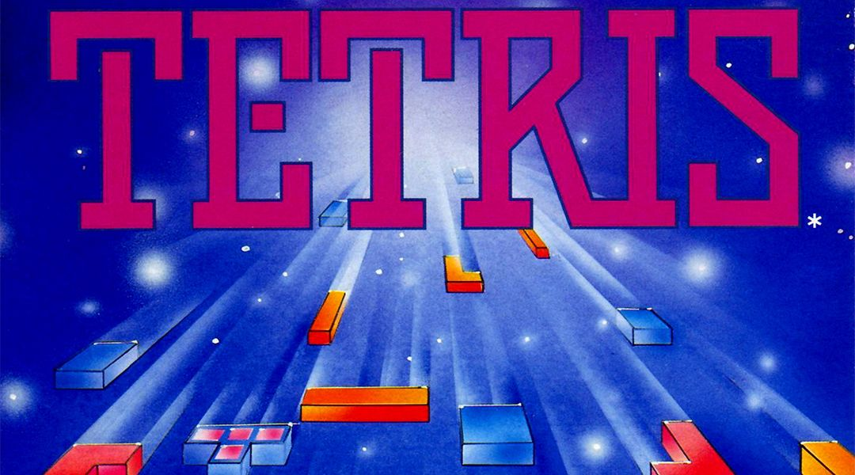

Table of Contents
Group Info 1
Part 1 - Project Management 2
Project Planning 2
Time Schedule 1
Group Meeting Records 3
Effort Summary 1
Peer Review 1
Purpose 1
Instructions 1
Section 1 – Self-Review [Your Name] 2
Section 2 – Peer Review (One per Team Member) 2
Section 3 – Self -Reflection 3
Peer Rating Summary Table 3
Score Adjustment Table 4
Part 2 - Requirement Analysis 5
Functional Requirements (FR) 5
Non-Functional Requirements (NFR) 9
Use Case Diagram 10
Activity Diagram 10
UML Class Diagrams 11
Part 3 - Implementation 11
GitHub 11
GitHub Advanced 11
File Structure 11
Coding Snippets 11
Part 4 - Demonstration 12
Demo Video Link 12

Group Info
Campus: Gold Coast
Group Number: 28
Group Members:
- Alexander Abbosh (s5173344)
- Christopher Burrell (s5237645)
- Vishva Pandya (s5255213)
- Bailey Reeves (s5189766)
Team Leader: Christopher Burrell
Lab Teacher: Larry Wen

Part 1 - Project Management

Project Planning

The following section comprises of the project planning details for Milestone 1. It outlines the major tasks, assigned responsibilities, estimated and actual completion times, as well as records of group meetings. This ensures transparency, effective time management, and clear communication within the team while tracking progress toward the development of the Tetris project.

Time Schedule

# | Task | Student | Planed Time | Actual Time | Cumulative Time | Finish Date
1 | Set up GitHub repository & permissions | CB | 1hr | 1hr | 1hr | 29/07/25
2 | Meeting- Project Kickoff | All | 1hr | 1hr | 2hr | 30/07/25
3 | Research JavaFX requirements & review demo | VP | 2hr | 2hr | 4hr | 31/07/25
4 | Draft Functional Requirements | AA | 1.5hr | 1.5hr | 6.5hr | 01/08/25
5 | Draft Non-Functional Requirements | CB | 1.5hr | 1.5hr | 7hr | 01/08/25
6 | Meeting – Review FR & NFR | All | 1hr | 0.5hr | 7.5hr | 02/08/25
7 | Create Use Case Diagram | AA | 1.5hr | 2hr | 9.5hr | 02/08/25
6 | Create Activity Diagram | AA | 2hr | 2hr | 11.5hr | 03/08/25
7 | Meeting – Review Use Case and Activity Diagrams | All | 1hr | 0.5hr | 12hr
8 | Implement Splash Window | AA | 1.5hr | 1.5hr | 13.5hr | 04/08/25
9 | Develop Main Screen navigation | VP | 2hr | 2hr | 15.5hr | 05/08/25
10 | Meeting – Review Splash Screen and Main Screen Nav | All | 1.5hr | 2hr | 17.5hr | 12/08/25
11 | Implement task checklists and Directory Setup | BR | 1.5hr | 1hr | 18.5hr | 13/08/25
12 | Implement Basic Gameplay Features (board, tetrominos, gameView) | BR | 3hr | 3hr | 21.5hr | 13/08/25
13 | Implement Tetrominos Movement from Player Input | BR | 3hr | 3hr | 24.5hr | 14/08/25
14 | Implement Tetrominos Rotation from Player Input | BR | 3hr | 2hr | 26.5hr | 14/08/25
15 | Implement Gravity Logic | BR | 3hr | 2.5hr | 29hr | 14/08/25
16 | Implement Piece Lock Logic | BR | 2hr | 2hr | 31hr | 14/08/25
17 | Implement Erase Full Rows Logic | BR | 2hr | 2.5hr | 33.5hr | 14/08/25
18 | Implement Game Over State | BR | 2hr | 2hr | 35.5hr | 14/08/25
19 | Meeting – Review Gameplay Basics | All | 1hr | 1hr | 36.5hr | 15/08/25
20 | Implement High Score Screen (dummy data) | CB | 2hr | 1hr | 37.5hr | 15/08/25
21 | Implement Pause/Resume Function | BR | 2hr | 1hr | 38.5hr | 15/08/25
22 | Implement Tetrominos Colour (CSS) | BR | 2hr | 1.5hr | 40hr | 15/08/25
23 | Adjust Aesthetics and Overall look of Game (CSS) | VP | 3hr | 3hr | 43hr | 16/08/25
24 | Implement Exit Function | BR | 2hr | 1hr | 44hr | 16/08/25
25 | Meeting – Functional/Non-Functional Requirements Check | All | 1.5hr | 1.5hr | 45.5hr | 18/08/25
26 | Meeting – Project Check-in | All | 1.5hr | 1hr | 46.5hr | 20/08/25
27 | Collect GitHub evidence (commits, pull requests, tags) | VP | 1hr | 1hr | 46.5hr | 20/08/25
28 | Record and edit demo video | VP | 4hr | 4hr | 50.5hr | 20/08/25
29 | Final review meeting & submission | All | 2hr | 2hr | 52.5hr | 21/08/25
30 | Compile, proofread, and finalise Milestone 1 report | CB | 3hr |  |  | 22/08/25
Table 1. Time Schedule chart. Abbreviations: Alexander Abbosh (AA), Christopher Burrell (CB), Vishva Pandya (VP), Bailey Reeves (BR).

Group Meeting Records

# | Meeting Topics | Attendance | Location | Software | Date and Time | Comments
1 | Project Kickoff & Role Allocation | AA, CB  (VP,BR chat only) | Online | Teams | 12am-1pm  30/07/2025 | Introduced team members, discussed project scope (Tetris), allocated roles based on strengths CB: Project Planning, Task Allocation, Peer Review, FR/NFR. AA: Splash Window, Use Case Diagram, Activity Diagram, Assist FR/NFR , VP: Main Screen, Config Screen, UI Navigation, GitHub Evidence, BR: Score system, Game Logic, pause functionality, exit function. Decided GitHub repository setup to be first task.
2 | Review FR & NFR | All | Online | Teams | 2pm – 2:30pm  01/08/2025 | CB and AA presented initial FR and NFR drafts. Group refined descriptions to ensure testability and consistency. Agreed to finalise FR/NFR before diagrams are started.
3 | Review Use Case Diagram | All | Online | Teams | 3pm-3:30pm  02/08/2025 | AA presented first draft of Use Case diagram. Team confirmed inclusion of all FRs. Suggested adding explicit “Pause Game” and “Exit Game” cases.
4 | Review Splash Screen and Main Screen Nav | AA,CB,VP  (BR Chat only) | Online | Teams | 12am-2pm  06/08/2025 | VP demonstrated Main Screen navigation flow. AA showed splash screen timing. Group confirmed navigation links between all screens worked as intended. Decided to move to Activity Diagram and high score logic next.
5 | Meeting Project Check-In | All | Online | Teams | 10am-10:30am  13/08/2025 | Reviewed progress on Milestone 1 tasks and confirmed all allocated sections were on track for completion by the due date. Each member provided a quick status update on their assigned work (FRs, NFRs, diagrams, and implementation tasks). Discussed any outstanding issues, including minor adjustments to wording in requirements and ensuring GitHub evidence was up to date. Agreed on the final timeline for compiling the report and recording the demo video.
6 | Meeting – Review Gameplay Basics | All | Online | Teams | 11am-12am  15/08/25 | The project team reviewed the core gameplay logic to ensure consistency with the intended design. BR provided an explanation of the logic of the board and tetromino movements, including how pieces spawn, rotate, and fit within the grid. The team discussed collision handling, scoring mechanisms, and conditions for line clearance. Members raised potential improvements to user interaction, such as display of next piece to spawn.
7 | Meeting - Functional/Non-Functional Requirements Check | All | Online | Teams | 11am-12:30pm  18/08/25 | The project team conducted a detailed review of the FRs & NFRs to ensure alignment with the project’s scope and objectives. Each member verified that their assigned requirements were clearly defined, measurable, and testable. The group identified minor inconsistencies in wording and overlaps between FRs & NFRs, which were revised for clarity. Additional emphasis was placed on performance, usability, and reliability requirements to support the gameplay experience. The team confirmed that all requirements are now finalized, forming the foundation for implementation and testing.
8 | Meeting – Project Check-In | All | Online | Teams | 12pm-2pm  21/08/25 | The team held a final catch-up session before submission to ensure all deliverables were complete and aligned with project requirements. Discussion focused on finalising the documentation, verifying that all sections were consistent, and cross-checking references to earlier milestones. In addition, the group reviewed the user interface presentation. As part of this process, styling code previously repeated across multiple views was abstracted into a central styles.css file for maintainability and cleaner design. The team confirmed readiness for submission following this refinement.
Table 2. Group Meeting Records. Abbreviations: Alexander Abbosh (AA), Christopher Burrell (CB), Vishva Pandya (VP), Bailey Reeves (BR).

Effort Summary
Student Name (#Id) | Planed hours | Actual hours
Alexander Abbosh (s5173344) | 16 | 118
Christopher Burrell (s5237645) | 18 | 16
Vishva Pandya (s5255213) | 20.5 | 16.5
Bailey Reeves (s5189766) | 34 | 31
Total working hours:
Average working hours per person

Peer Review

Section 1 – Self-Reviews

Self Review - Alexander Abbosh

1. What was your primary role in this milestone?
My primary role in this milestone was the preliminary design of the game and the startup screen.
2. What specific tasks or deliverables did you complete?
I did the Use Case, Activity, and UML Diagrams for the project as well as the startup screen for the game. I also helped structure the project plan to make it easier to navigate for teammates.
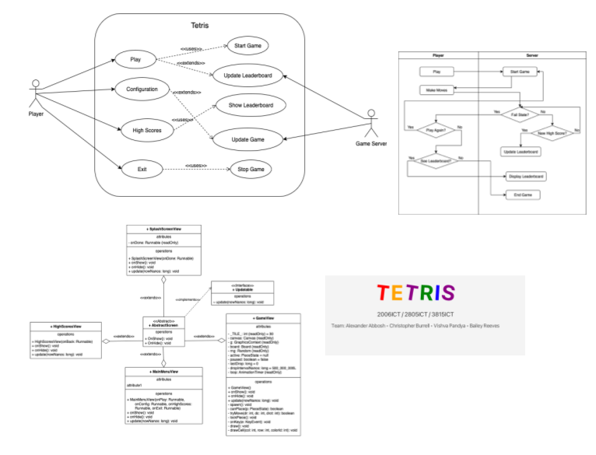
Figure 1. Clockwise from Top Left. Use Case Diagram, Activity Diagram, Splash Screen, UML of AbstractScreen.

3. What challenges, if any, did you face while contributing to the project?
Some of the challenges faced included making sure everyone contributed equally to the overall project, as well as making sure the splash screen doesn’t mess up any other parts of the game.
4. What is one aspect of your contribution that you would like to improve in the next milestone?
I’d like to contribute to the functional and non-functional requirements as well as a bit more to the coding of the project itself.
5. On a scale of 1 to 10, how would you rate your overall contribution to the team?
Overall, I’d rate my contribution to the team at around 7/10.

Self-Review – Christopher Burrell
1. What was your primary role in this milestone?
My role included setting up the initial repository on GitHub and guiding others to that. After initial group meetings I was designated team leader and helped delineate tasks. I provided project management and most of the project plan. I also helped code issues around navigation between program views and some of the visual elements of the program.
2. What specific tasks or deliverables did you complete?
I delivered the Project Plan, Functional Requirements, Implementation of GitHub, Peer Review and assisted in Project Management.
3. What challenges, if any, did you face while contributing to the project?
Basic understanding of the IntelliJ IDE was confusing at first after not having used it before. Additionally, the management of git and branches proved challenging, with multiple branches and the management of the repo’s pull requests.
4. What is one aspect of your contribution that you would like to improve in the next milestone?
The overall git management I want to improve on for the next milestone, by helping the team create and checkout different branches, and to keep the main branch clear of changes until proven operational and checked off by all members.
5. On a scale of 1 to 10, how would you rate your overall contribution to the team?
I would give myself a 7/10. I completed my tasks with room for improvement.

Self-Review – Vishva Pandya
1. What was your primary role in this milestone?
My role was front screen developer for the main menu and navigation, and tester for functionality. I worked on the main screen, configuration screen, ensured all UI screens were connected, and contributed GitHub commits, pull requests, and tags.
2. What specific tasks or deliverables did you complete?
I designed and implemented the main menu UI, built navigation between screens, tested functionality, debugged navigation issues, and assisted in peer testing.
3. What challenges, if any, did you face while contributing to the project?
I faced issues with cloning the repository, branch management, and errors in committing and pushing code, which caused delays.
4. What is one aspect of your contribution that you would like to improve in the next milestone?
I want to improve time management and seek support earlier when facing technical issues.
5. On a scale of 1 to 10, how would you rate your overall contribution to the team?
7 out of 10 – I completed my tasks and testing but can improve efficiency and speed in handling technical problems.

Self-Review – Bailey Reeves

1. What was your primary role in this milestone?
My primary role in this milestone was Game Logic Lead. I was responsible for ensuring the core gameplay systems (such as piece movement, collision detection, scoring, and game state management) were implemented correctly and worked smoothly with the rest of the project.
2. What specific tasks or deliverables did you complete?
I worked on the majority of the gameplay coding, including piece spawning, movement, rotation, collision detection, scoring, line clearing, and handling game states like pause and game over. Teammates supported by creating the main menu, high score screen, and config screen, while I concentrated on the in-game functionality.
3. What challenges, if any, did you face while contributing to the project?
Getting familiar with JavaFX tools like GraphicsContext and timelines. Also ensuring the timer and game state transitions behaved correctly during pause or game over. Additionally, balancing time between coding and testing, since gameplay required a lot of trial and error.
4. What is one aspect of your contribution that you would like to improve in the next milestone?
I’d like to focus on anticipating future features earlier. For example, planning ahead for saving and reusing data such as scores would make it easier to integrate gameplay with menus and high score tracking later. I’d also like to get better at testing and refining edge cases (like pause and game-over states) to make the game feel smoother overall.
5. On a scale of 1 to 10, how would you rate your overall contribution to the team?
I’d rate myself around 8.5/10. I put a lot of effort into getting the gameplay functional, but there are still areas where I can refine and collaborate better with the team moving forward.

Section 2 – Peer Reviews

Peer Review - Alexander Abbosh

Reviewee Name: Christopher Burrell
1. What was this team member’s main role during this milestone?
They were responsible for the project planning, functional, non-functional requirements, collecting peer feedback and helping with coding.
2. What were their key contributions?
They created the functional and non-functional requirements that helped steer later stages of the project.
3. How would you evaluate their professionalism?
They were very professional, always communicating well and supporting teammates.
4. What is one respectful and specific suggestion for how they could improve in the next phase?
They were great at getting stuff done for the project, but sometimes they could maybe allocate some tasks to others to help shoulder the burden and take some pressure of them. This would allow for everyone in the group to feel they contributed equally and had more accountability over how the final project performs.
5. On a scale of 1 to 10, how would you rate their overall contribution to the team?
I would rate them a 10. They were great at guiding the overall direction of the project and always completed tasks in an efficient and effective manner and communicated well with the team.

Reviewee Name: Vishva Pandya
1. What was this team member’s main role during this milestone?
This team member’s main role was UI Implementation, documenting GitHub activities and creating the initial task allocation split.
2. What were their key contributions?
They made the UI of the game look intuitive and stylish and also created a four way task split to help evenly divide the workload.
3. How would you evaluate their professionalism?
They were very professional, always keeping in contact with other group members.
4. What is one respectful and specific suggestion for how they could improve in the next phase?
Nothing comes to mind at the time of writing.
5. On a scale of 1 to 10, how would you rate their overall contribution to the team?
I would give them a 10. They were instrumental in helping divide the workload, always asked others if they needed any support with their tasks and helped make the menu screen look good.

Reviewee Name: Bailey Reeves
1. What was this team member’s main role during this milestone?
They were the Game logic lead, which involved implementing the layout of the game, displaying scores, and the game rules.
2. What were their key contributions?
Their key contributions were making sure the game worked correctly and making it look good.
3. How would you evaluate their professionalism?
Very professional. They always communicated promptly and clearly with what they were doing with the project.
4. What is one respectful and specific suggestion for how they could improve in the next phase?
Contribute a bit more to the initial task allocation process so that they don’t feel the need to handle a large majority of the coding aspect of the task.
5. On a scale of 1 to 10, how would you rate their overall contribution to the team?
I would rate them a 10, they went above and beyond and were essential when it came delivering a functional game.

Peer Review - Christopher Burrell

Reviewee Name: Alexander Abbosh
1. What was this team member’s main role during this milestone?
Alexander was responsible for the splash window, use case and activity diagrams, and aligning diagrams with requirements.
2. What were their key contributions?
Delivered a working splash screen, created accurate diagrams, and explained design decisions in the report. Helped walk through the
3. How would you evaluate their professionalism?
Very professional and consistent; he communicated well and kept tasks on schedule.
4. What is one respectful and specific suggestion for how they could improve in the next phase?
He could provide drafts of diagrams earlier to allow more group review before finalising. Also, further development with branches and git control.
5. On a scale of 1 to 10, how would you rate their overall contribution to the team?
10/10. Alex did what was asked of him, communicated well, offered help to others, had self-drive and was a credit to the team.

Reviewee Name: Vishva Pandya
1. What was this team member’s main role during this milestone?
Vishva focused on main menu development, helped with the screen navigation, configuration UI, and GitHub evidence. She also recorded and narrated the project groups video evidence.
2. What were their key contributions?
Delivered smooth navigation between screens, designed the main and configuration menus. Vishva also delivered the programs operational evidence, and git control history.
3. How would you evaluate their professionalism?
Professional and collaborative, always open to feedback and responsive during meetings. Had great ideas and helped implement where needed.
4. What is one respectful and specific suggestion for how they could improve in the next phase?
Git control was her only issue; however, she was able to operate effectively when needed.
5. On a scale of 1 to 10, how would you rate their overall contribution to the team?
10/10. When tasked with a job she immediately worked on it where possible, and was able to

Reviewee Name: Bailey Reeves
1. What was this team member’s main role during this milestone?
Bailey role was implementing much of the core gameplay logic and functionality. This included how the board operated, how tetrominos moved and rotated, and ensured the scoring and game rules functioned properly.
2. What were their key contributions?
Bailey implemented the file structure, and main coding elements that helped deliver the core functionality of the Tetris game. This included all core game features, the board, scoring, line deletion etc.
3. How would you evaluate their professionalism?
Very professional, supportive, and consistently clear in communication.
4. What is one respectful and specific suggestion for how they could improve in the next phase?
As far as his comments were concerned in code it was appropriate, but a little bit more communication with features and operations before pushing them would be appreciated. Git control could also be improved.
5. On a scale of 1 to 10, how would you rate their overall contribution to the team?
10/10. Coded cleanly, worked efficiently, communicated clearly and correctly when required.

Peer Review - Vishva Pandya

Reviewee Name: Alexander
1. What was this team member’s main role during this milestone?
Alexander’s main role was creating the splash window, developing the use case and activity diagrams, writing explanations for the report, and ensuring requirements matched the diagrams.
2. What were their key contributions?
He delivered the splash window to meet requirements, completed clear and accurate diagrams, wrote supporting explanations for the report, and collaborated to align requirements with diagrams. His work was consistent and high quality.
3. How would you evaluate their professionalism?
Alexander was reliable, worked well with the team, communicated clearly, and completed tasks on time.
4. What is one respectful and specific suggestion for how they could improve in the next phase?
He could add more detail to diagrams earlier so the team has more time for review.
5. On a scale of 1 to 10, how would you rate their overall contribution to the team?
I would rate his contribution as 10 out of 10. He delivered all assigned work to a high standard and was a reliable team member throughout the milestone.

Reviewee Name: Christopher
1. What was this team member’s main role during this milestone?
Christopher’s main role was project planning, including task allocation, timeline management, meeting summaries, peer review summaries, and documenting functional requirements.
2. What were their key contributions?
He completed all tasks thoroughly, led project planning, communicated well, and ensured requirements were accurate. His high-quality work kept the team organised.
3. How would you evaluate their professionalism?
Christopher was reliable, responsive, and clear in communication. His collaboration helped the team stay on track.
4. What is one respectful and specific suggestion for how they could improve in the next phase?
Christopher could focus on delegating more responsibilities to other team members to avoid becoming overloaded and to help balance the workload across the team.
5. On a scale of 1 to 10, how would you rate their overall contribution to the team?
I would rate his contribution as 10 out of 10. He exceeded expectations in planning, communication, and report preparation.

Reviewee Name: Bailey Reeves
1. What was this team member’s main role during this milestone?
Bailey’s main role was developing the high score screen (dummy data, back button), gameplay field (10×20 grid, piece movement, controls), erase full rows logic, pause function (P key toggle and message), and exit function (confirmation dialog).
2. What were their key contributions?
He produced a high-quality gameplay system with all assigned features working smoothly and to a high standard.
3. How would you evaluate their professionalism?
Bailey was reliable, responsive, and worked well as a team collaborator.
4. What is one respectful and specific suggestion for how they could improve in the next phase?
He could improve by documenting his code clearly.
5. On a scale of 1 to 10, how would you rate their overall contribution to the team?
10 out of 10 – he delivered all tasks to a high standard and was a dependable team member.

Peer Review – Bailey Reeves

Reviewee Name: Alexander Abbosh
1. What was this team member’s main role during this milestone?
Alexander’s main role was UML and Analysis Lead, creating diagrams and aligning system requirements with visual models.
2. What were their key contributions?
He developed UML diagrams such as the Use Case and Activity diagrams, adding written explanations alongside them. He also worked on the splash screen and double-checked requirements against the diagrams to make sure everything lined up. His diagrams were clear and strengthened the analysis section of the report.
3. How would you evaluate their professionalism?
Alexander worked well with the team, communicated openly, and followed through on his tasks. He was responsive to feedback and used it to improve his work.
4. What is one respectful and specific suggestion for how they could improve in the next phase?
One area to build on could be taking a bit more initiative in suggesting or picking up extra tasks. He did really solid work, and stepping in more actively at times could make an even bigger impact on the group’s progress.
5. On a scale of 1 to 10, how would you rate their overall contribution to the team? 9/10
9/10

Reviewee Name: Christopher Burrell
1. What was this team member’s main role during this milestone?
Christopher was designated as our Group Leader. His main role was Project Planning & Documentation Lead, with responsibility for structuring the project timeline, allocating tasks, and keeping documentation consistent across the group.
2. What were their key contributions?
He consistently produced clear planning documents including task breakdowns, meeting notes, and allocations. His work on Functional and Non-Functional Requirements was detailed, covering both technical and user-focused aspects. Chris also played a big part in proofreading and tying the final report together, so it flowed as one piece.
3. How would you evaluate their professionalism?
Chris was highly professional throughout the project. He communicated clearly, stayed organised, and always responded promptly which helped keep the team on track with deadlines.
4. What is one respectful and specific suggestion for how they could improve in the next phase?
One suggestion would be to share out some of the documentation load more evenly. This could free him up to focus even more on higher-level coordination and decision-making.
5. On a scale of 1 to 10, how would you rate their overall contribution to the team?
9/10

Reviewee Name: Vishva Pandya
1. What was this team member’s main role during this milestone?
Vishva’s main role was UI Implementation and GitHub Lead, with a focus on building screen navigation and managing GitHub activity.
2. What were their key contributions?
She built the main menu, configuration screen, and smooth navigation between multiple screens, giving us a functional flow from splash screen through gameplay. On top of that, her GitHub management — commits, pull requests, and tagging — provided clear evidence of strong version control and progress.
3. How would you evaluate their professionalism?
Vishva was reliable and consistent with her work. She made steady progress on the technical side and was proactive in making sure different parts of the project integrated smoothly.
4. What is one respectful and specific suggestion for how they could improve in the next phase?
For the next stage, it could help if she added more written notes or documentation about her GitHub processes and UI decisions. That way the rest of the team can easily follow along and pick things up if needed.
5. On a scale of 1 to 10, how would you rate their overall contribution to the team?
9/10

Section 3 – Self -Reflection
Project team members reflect on learnings and team experience during this milestone 1.

Self-Reflection – Alexander Abbosh

Self-Reflection – Christopher Burrell
1. Was the peer review process fair and helpful in identifying your contributions and role within the team?
Yes, I believe the process was fair. The reviews reflected that I was primarily responsible for working on the UI styling, GitHub management, and helping with integration, which is exactly the role I played. It showed that my contributions were recognised and aligned with how I saw my involvement.
2. Did the feedback you received help you identify any areas for personal or team improvement?
Yes, it did. A couple of comments mentioned that I could contribute more during the coding phase instead of focusing mainly on integration and styling. While I was comfortable in that role, I can see the value of spreading my input more evenly across different aspects of the project. Another point raised was to document my Git/GitHub processes more clearly so the rest of the team can follow along more easily, which I think is a good suggestion.
3. On a scale of 1 to 10, how useful was this peer review cycle for your learning and team development?
I would give it an 8/10. It was useful because it confirmed that my contributions were noticed and also highlighted areas where I could push myself to take on more responsibility in future milestones.
4. How did you respond to the feedback you received from your peers?
I agreed with most of the comments. For the next milestone I will aim to participate more actively in the coding side, not just in styling and GitHub management. I will also improve the clarity of my documentation around merging, pushing, and conflict resolution, so the whole team can benefit from those practices.

Self-Reflection – Vishva Pandya
1. Was the peer review process fair and helpful in identifying your contributions and role within the team?
Yes, I found the peer review process to be fair and accurate. My peers clearly recognized my main role as UI Implementation and GitHub Lead, which aligns with what I contributed during this milestone. They highlighted my work on creating the menu, configuration screens, and smooth navigation flow, as well as my GitHub management and task allocation efforts. I feel this feedback was balanced and reflective of my actual involvement.
2. Did the feedback you received help you identify any areas for personal or team improvement?
Yes, one useful takeaway from the feedback was the suggestion to add more documentation and written notes about my GitHub processes and UI decisions. While my technical work was recognized, improving documentation will make it easier for the team to follow along, maintain consistency, and pick up tasks if needed. This insight will help me focus on improving team transparency in the next stage.
3. On a scale of 1 to 10, how useful was this peer review cycle for your learning and team development?
I would rate this cycle a 9/10. The reviews validated my contributions, gave me constructive feedback, and also showed that the team valued my efforts. The process encouraged me to reflect on how I can continue to contribute effectively while also improving collaboration.
4. How did you respond to the feedback you received from your peers?
I agreed with the feedback, especially the point about documentation. It encouraged me to consider how my work can be made more accessible for others. Moving forward, I will make an effort to provide clearer notes, comments, and written explanations of my design choices and GitHub actions. This will help strengthen collaboration and ensure smoother handovers in future project phases.

Self-Reflection – Bailey Reeves
1. Was the peer review process fair and helpful in identifying your contributions and role within the team?
Yes, I thought it was fair. The reviews recognised that I was mainly responsible for the gameplay coding and that matched the role I actually took on. It gave an accurate picture of what I contributed to this milestone.
2. Did the feedback you received help you identify any areas for personal or team improvement?
It did. Some of the comments suggested I could improve my code documentation. I feel I put a good amount of comments into my code already, but I can see the value in making some of them more descriptive or high-level so it’s even clearer for others who weren’t directly involved in the gameplay logic. Another point was to be more active in the early planning stage, which I agree with and will aim to do.
3. On a scale of 1 to 10, how useful was this peer review cycle for your learning and team development?
I’d give it an 8/10. It was useful for confirming that my main contributions were recognised, and it also gave me a couple of good takeaways for how I can work better with the team in future milestones.
4. How did you respond to the feedback you received from your peers?
I agreed with it overall. For the next milestone I’ll aim to make my code comments more descriptive for teammates and also take a bigger role in the initial task discussions, so the workload feels more evenly balanced across the group.

Peer Rating Summary Table
The peer rating summary table presents an evaluation of each group member’s contribution to the project. Each team member assessed the efforts of their peers on a scale of 1 to 10, with scores reflecting participation, quality of work, and collaboration throughout the assignment.

Reviewer/ Reviewee | Alexander Abbosh | Christopher Burrell | Vishva Pandya | Bailey Reeves
Alexander Abbosh | N/A | 10 | 10 | 10
Christopher Burrell | 10 | N/A | 10 | 10
Vishva Pandya | 10 | 10 | N/A | 10
Bailey Reeves | 9 | 9 | 9 | N/A
Total Score | 29 | 29 | 29 | 30
Average Score | 9.7 | 9.7 | 9.7 | 10
Table 3. Project Team Effort Summary Planned/Actual Hours of Work

Score Adjustment Table
Based on individual student’s average review score, the student’s mark would be adjusted based on the table below.
% Difference from Group Avg | Score Adjustment
Over 50% above/below | Instructor discretion
40–50% above | +10%
21–40% above | +8%
11–20% above | +5%
±10% | No change
11–20% below | –10%
21–40% below | –20%
40–50% below | –30%

Part 2 - Requirement Analysis

Functional Requirements (FR)
The following section provides the Functional Requirements which define the essential features and behaviours of the Tetris game as demonstrated in the Milestone 1 scope. They specify the expected interactions between the user and the system, covering all main components:
- Splash Screen
- Main Menu
- Configuration Settings
- High Score Display
- Core Gameplay Functionality
Each requirement is expressed in terms of precondition, event, and post condition formatting to maintain clarity, testability, and alignment with the milestone demonstration.
Functional Requirements (FR)
FR-01 Splash Screen
Description: Displays a brief introductory screen with group and course details before the main menu.
Precondition: App not yet on Main Screen.
Event: User launches the application.
Postcondition: A cantered splash window shows group identity and course info for a few seconds, then closes to the Main Screen.

FR-02 Main Screen Layout

Description: Provides the main navigation hub with all core menu options.
Precondition: App has launched, or user has returned from another screen.
Event: Main Screen is displayed.
Postcondition: Main Screen shows four buttons: Play, Configuration, High Scores, Exit.

FR-03 Play Navigation

Description: Starts a new game session from the main menu.
Precondition: Main Screen visible.
Event: User clicks Play.
Postcondition: Game Screen opens with a new game initialised.

FR-04 Configuration Navigation

Description: Opens the settings interface to adjust gameplay options.
Precondition: Main Screen visible.
Event: User clicks Configuration.
Postcondition: Configuration Screen opens.

FR-05 High Scores Navigation

Description: Opens the leaderboard screen showing top results.
Precondition: Main Screen visible.
Event: User clicks High Scores.
Postcondition: High Score Screen opens showing a Top 10 list (dummy data acceptable in Milestone 1).
FR-06 Return Main Menu

Description: Allows user to return to the main menu from any other screen.
Precondition: User is on any screen other than the Main Screen (e.g., High Scores, Configuration, Game Over).
Event: User clicks the Back button or selects the main menu option.
Postcondition: Main Screen opens, displaying all primary navigation options (Play, Configuration, High Scores, Exit).

FR-07 Exit Navigation

Description: Initiates the process to close the application.
Precondition: Main Screen visible.
Event: User clicks Exit.
Postcondition: Exit confirmation dialog appears with Yes and No.

FR-08 Exit Confirm – Yes

Description: Confirms and closes the application.
Precondition: Exit dialog visible.
Event: User selects Yes.
Postcondition: Application terminates.

FR-09 Exit Confirm – No

Description: Cancels exit request and returns to main menu.
Precondition: Exit dialog visible.
Event: User selects No.
Postcondition: Dialog closes; Main Screen remains.

Configuration Screen (per provided UI)

FR-10 Config Controls Respond

Description: Ensures all sliders and checkboxes update their display state immediately when interacted with.
Precondition: Configuration Screen visible.
Event: User interacts with controls.
Postcondition:

- Field Width (cells): Slider/selector updates value label live.
- Field Height (cells): Slider/selector updates value label live.
- Game Level: Slider/selector updates value label live.
- Music (On/Off): Checkbox toggles state and label (On/Off).
- Sound Effect (On/Off): Checkbox toggles state and label (On/Off).
- AI Play (On/Off): Checkbox toggles state and label (On/Off).
- Extend Mode (On/Off): Checkbox toggles state and label (On/Off).
* No gameplay binding required at Milestone 1; interaction must be visible and correct.

Gameplay (Milestone-1 scope)

FR-11 Game Field Setup

Description: Displays the playfield and spawns the first tetromino.
Precondition: User started a game (FR-03).
Event: Game Screen loads.
Postcondition: A 10×20 playfield is rendered; an active tetromino spawns at the top; colours/shapes render consistently.

FR-12 Movement & Rotation Controls

Description: Enables player to control the active tetromino.
Precondition: Game running and not paused.
Event: User presses arrow keys (Left/Right to move; Up or designated key to rotate; Down for soft drop if implemented).
Postcondition: Tetromino moves/rotates smoothly within bounds and without overlapping fixed blocks.

FR-13 Gravity & Lock

Description: Moves tetrominoes downward automatically and fixes them in place when resting
Precondition: Game running.
Event: Gravity tick or piece reaches rest (no valid downward move).
Postcondition: Piece locks into the field; next tetromino spawns unless game over.

FR-14 Clear Full Rows

Description: Removes any fully filled horizontal lines.
Precondition: A piece has just locked.
Event: System checks board state.
Postcondition: All complete rows are removed in one operation; rows above drop; colours remain correct; multiple-row clears are handled.

FR-15 Pause / Resume

Description: Temporarily halts and resumes gameplay.
Precondition: Game running.
Event: User presses P.
Postcondition:

- If running → game enters Paused state and shows a visible “Paused” message.
- If paused → game resumes and message is cleared.

FR-16 Game Over

Description: Detects when no further pieces can spawn.
Precondition: Game running.
Event: New tetromino cannot spawn due to blocked spawn cells.
Postcondition: Game ends; “Game Over” state/message shown with a way to return to the Main Screen.

Non-Functional Requirements (NFR)

This section describes the quality attributes and operational constraints of the system rather than the specific behaviours it performs. These define how the system should operate under certain conditions and ensure it meets user expectations for usability, reliability, performance, and supportability. One NFR for each of the URPS categories in the FURPS+ model has been provided, each of which can be implemented using basic Java/JavaFX features.

NFR-U01 Colour Blindness Support (Usability)
Requirement: The Configuration screen must include a “Colour Blindness” setting allowing the user to select a type (e.g., Deuteranopia, Protanopia, Tritanopia). The game will replace affected colours with an alternative colour for better visibility.
Verification: Select each type in Configuration, start a game, and confirm colours are replaced according to the chosen setting.
NFR-R01 Game Stability (Reliability)

Requirement: The application must run for at least 20 minutes, navigating between screens and playing without crashing or showing error messages.
Verification: Manually run the application in a lab test for 20 minutes; pass if no crashes or unhandled exceptions occur.

NFR-P01 Smooth Gameplay (Performance)

Requirement: Gameplay must maintain at least 30 frames per second (FPS) on standard lab hardware while pieces move and rotate.
Verification: Play for 5 minutes; visually confirm smooth piece movement with no noticeable lag.

NFR-S01 Easy Build and Run (Supportability)

Requirement: The game must compile and run from a clean clone using Java 21 and JavaFX, with no manual code changes required.
Verification: Freshly clone the GitHub repository, build, and run using the provided instructions; pass if successful without errors.

Use Case Diagram

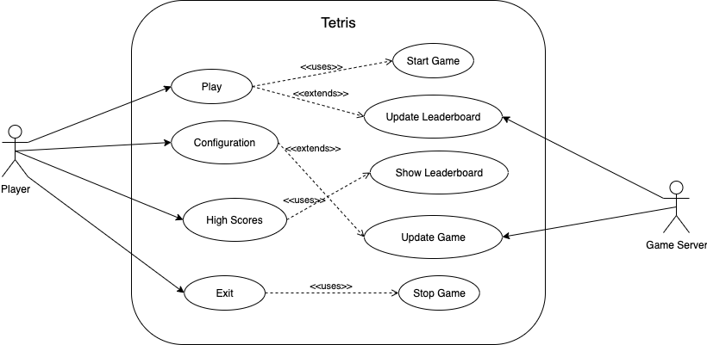
Figure 2. Use Case Diagram for Tetris Game

The diagram Figure 2 illustrates the interactions between the player, the game server, and the core functionalities of the Tetris system. The player can initiate gameplay, configure settings, view high scores, and exit the game. System processes extend these actions to include starting and stopping the game, updating the game state, and managing the leaderboard. The game server supports backend operations such as updating the leaderboard and game state.

Activity Diagram

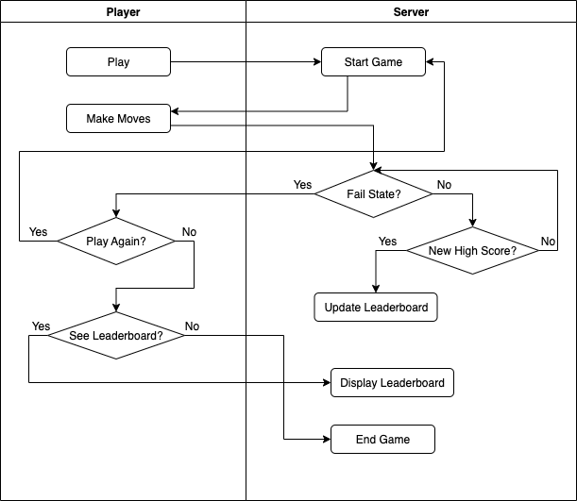
Figure 3. Activity Diagram for Tetris Gameplay Flow

This activity diagram, Figure 3, illustrates the sequence of interactions between the player and the server throughout the Tetris gameplay lifecycle. It outlines the process starting from initiating the game, making moves, and encountering a fail state, to updating the leaderboard if a new high score is achieved. The diagram also represents decision points for replaying the game or viewing the leaderboard, before eventually ending the game session.

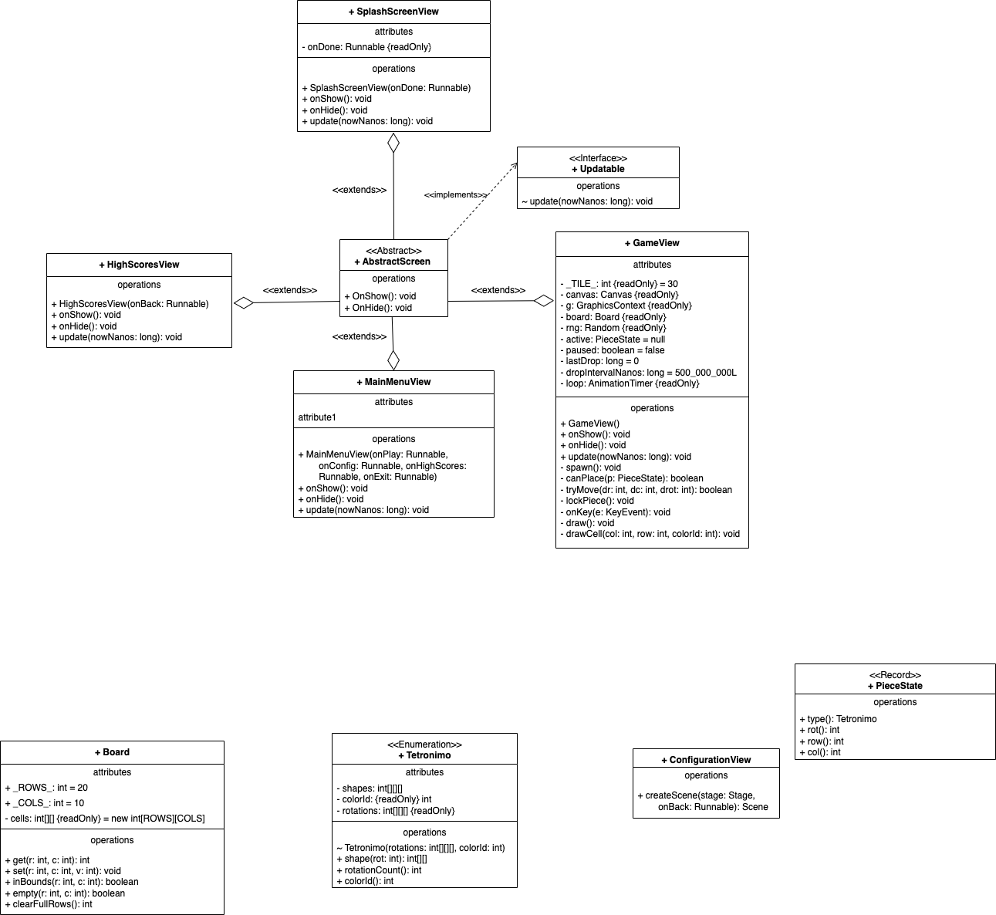
UML Class Diagrams
Figure 4. AbstractScreen and Related Classes

Figure 4 demonstrates the structure and relationships between the AbstractScreen class, its concrete subclasses (SplashScreenView, HighScoresView, MainMenuView, and GameView), and the Updatable interface. The AbstractScreen class serves as a base class defining shared operations (onShow() and onHide()), which are extended by the various screen classes to implement their specific functionality. The Updatable interface enforces an update() method, implemented by the classes to handle real-time updates during gameplay and navigation. The diagram highlights how the system’s screen management and game logic are modularised through inheritance and interface implementation, ensuring code reusability and clear separation of responsibilities.

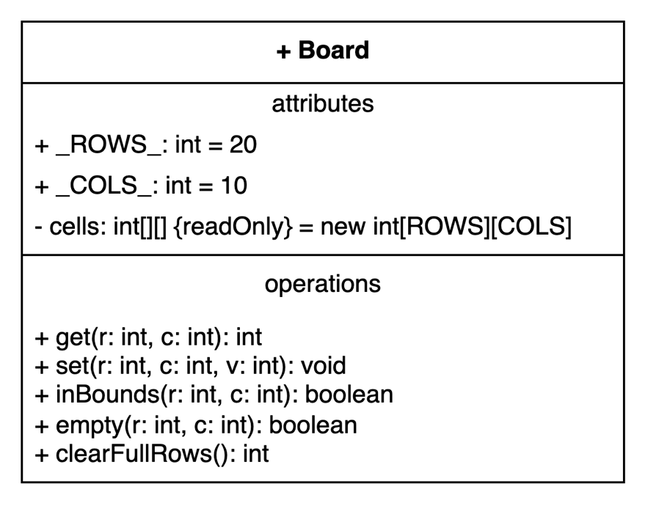
Figure 5. UML Class Diagram of Board Class

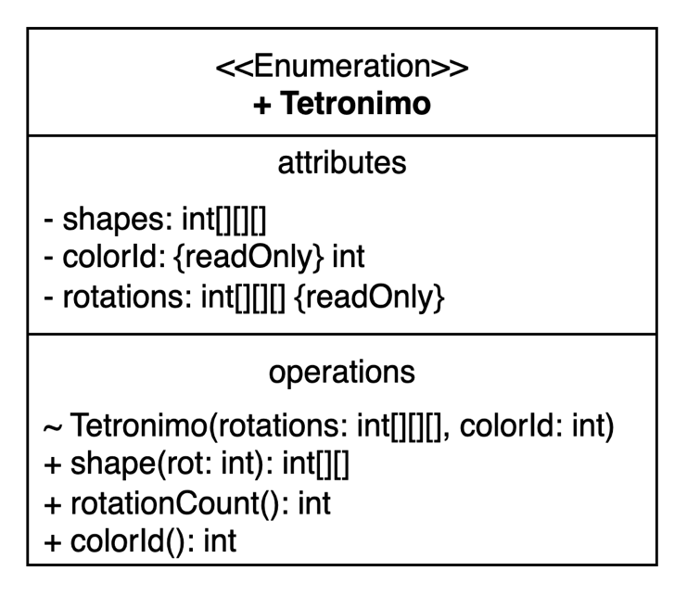
Figure 6. UML Enumeration Diagram for Tetromino

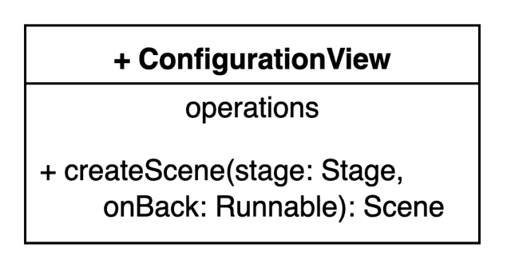
Figure 7. UML Diagram of the ConfigurationView Class

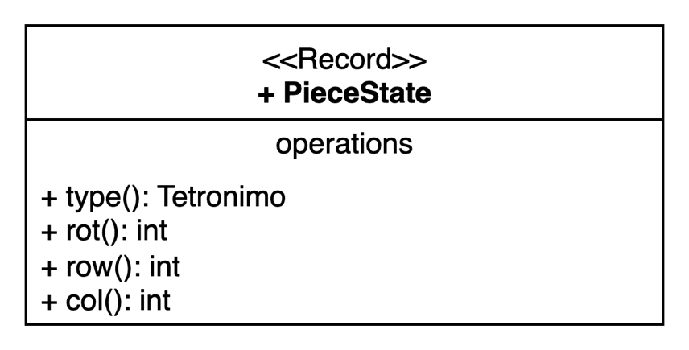
Figure 8. PieceState UML Diagram

The structural design of the program is represented through several UML diagrams that capture the relationships between key classes and components. Figure 5. UML Class Diagram of the Board Class shows the core game logic responsible for piece placement, collision detection, line clearing, and scoring, which forms the backbone of the gameplay. Complementing this, Figure 6. UML Enumeration Diagram for Tetromino defines the different Tetris shapes and their possible orientations, ensuring standardised handling of game pieces across the system. The user interface aspects are reflected in Figure 7. UML Diagram of the ConfigurationView Class, which provides a screen for adjusting settings, even though some of its functions are currently non-operational, highlighting planned extensibility for future development. Finally, Figure 8. PieceState UML Diagram describes the record structure used to store and manage the current state of an active piece, including its type, rotation, and position on the board, allowing smoother gameplay updates. Together, these diagrams provide an overview of the program’s core logic, user interface elements, and data structures.

Part 3 - Implementation

GitHub

GitHub Link:
https://github.com/crashbox-hub/OOSD_Tetris_PG28.git

Screenshot of Commit History:
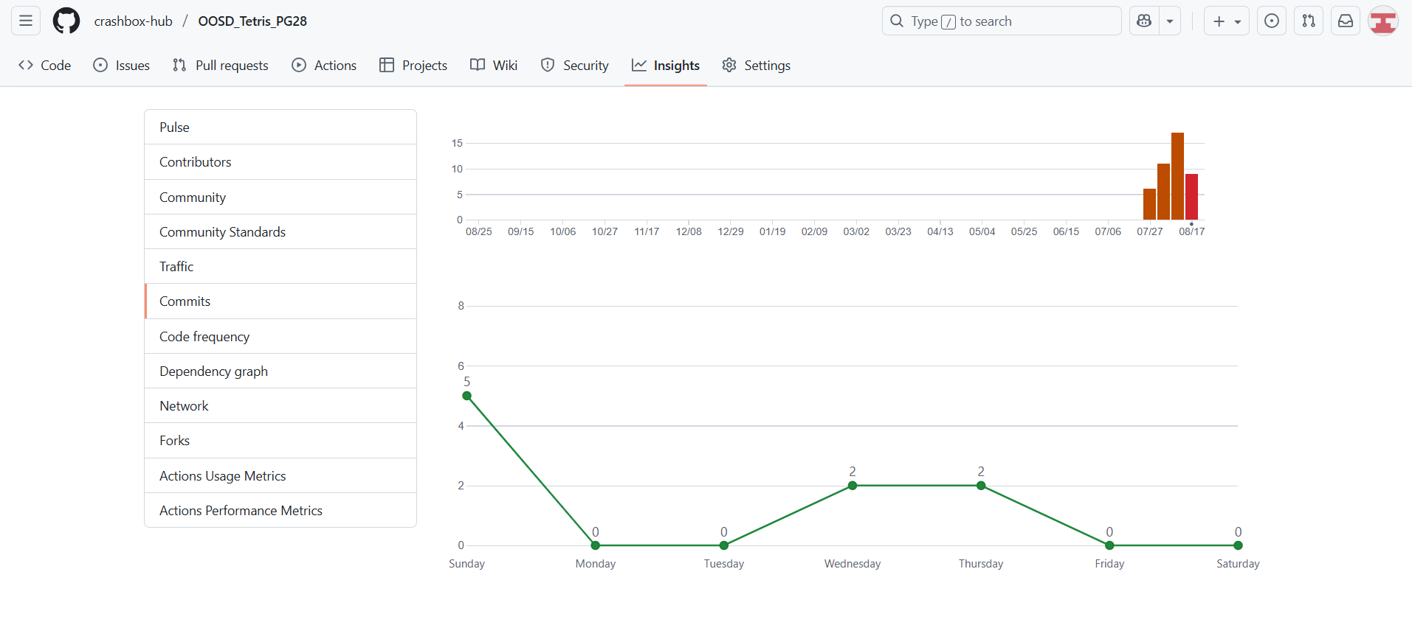
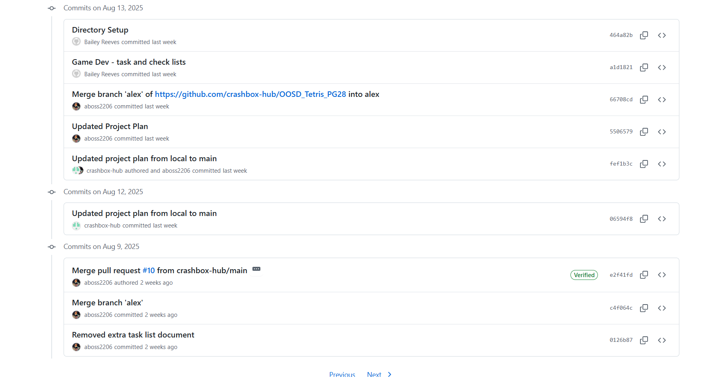
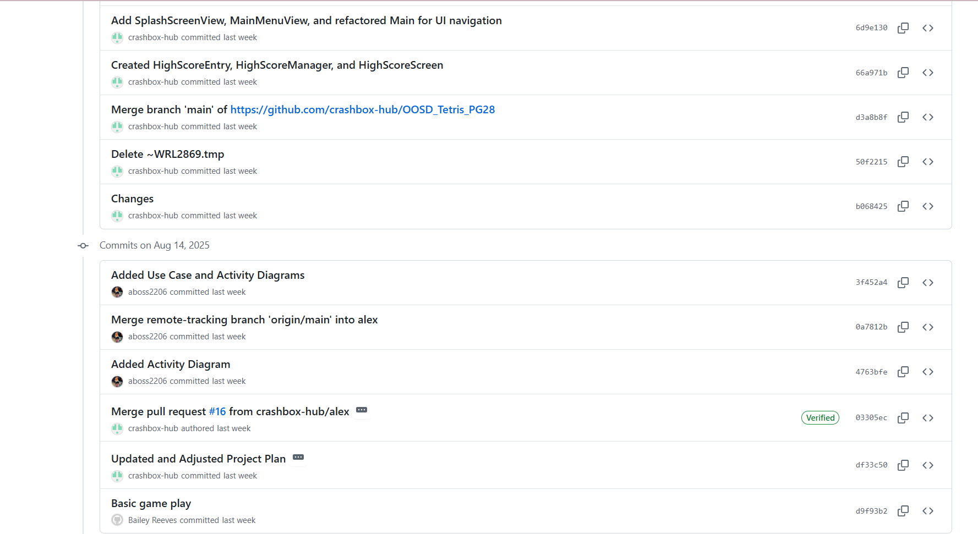
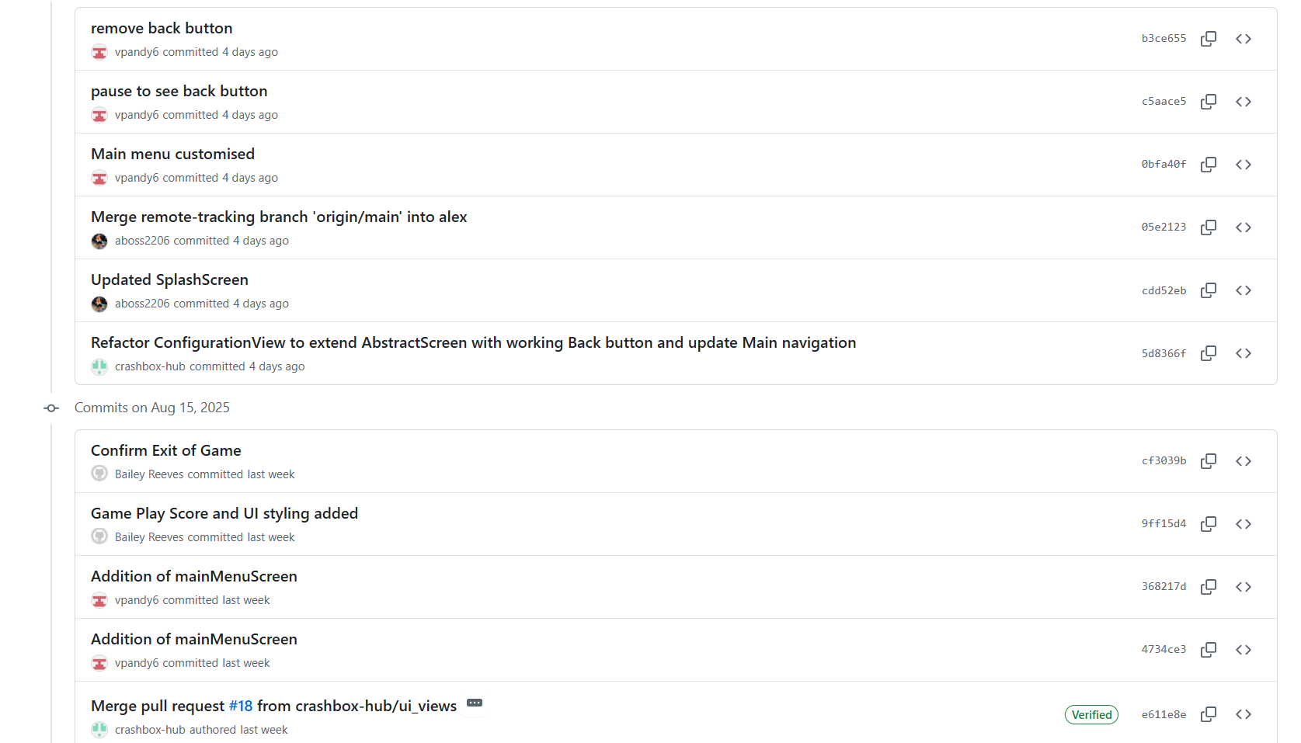
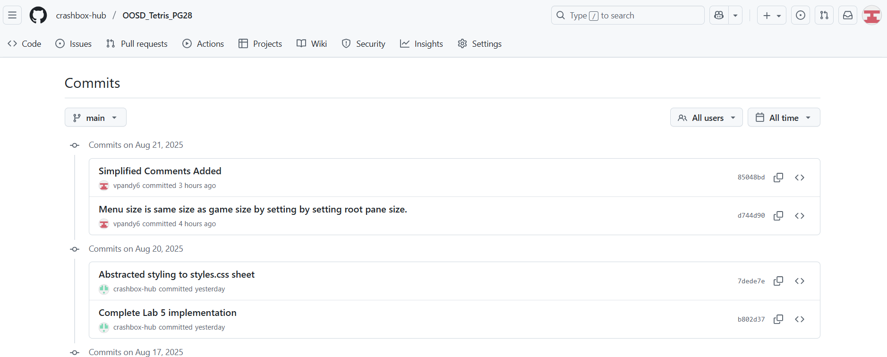

GitHub Advanced

Screenshot of Pull Requests:
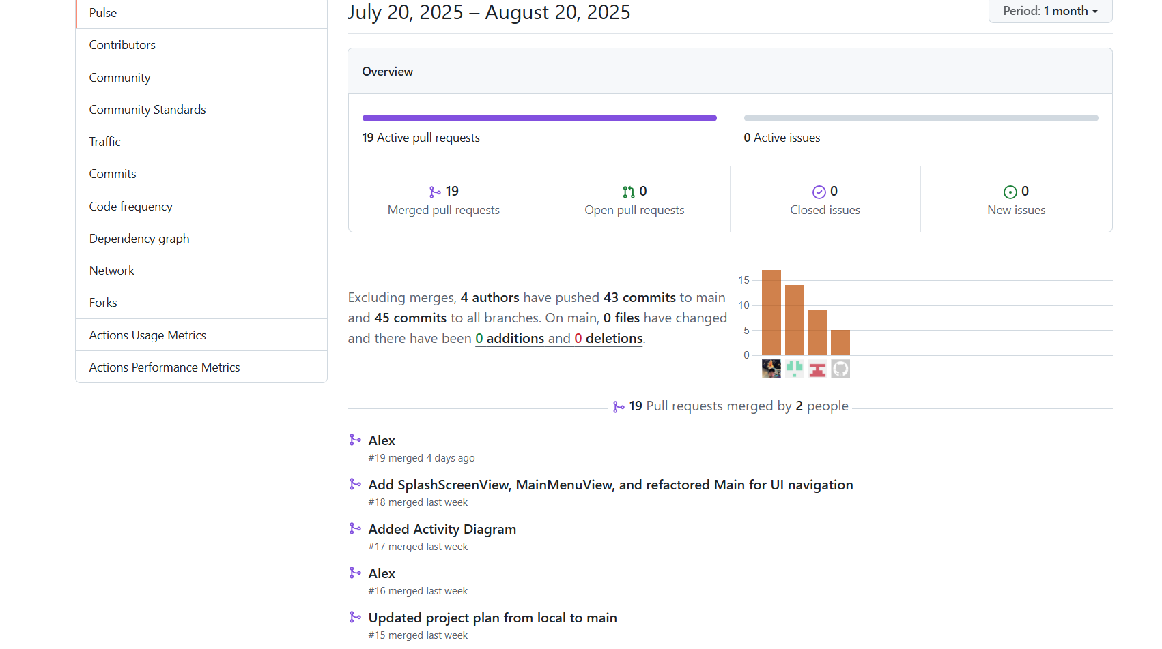
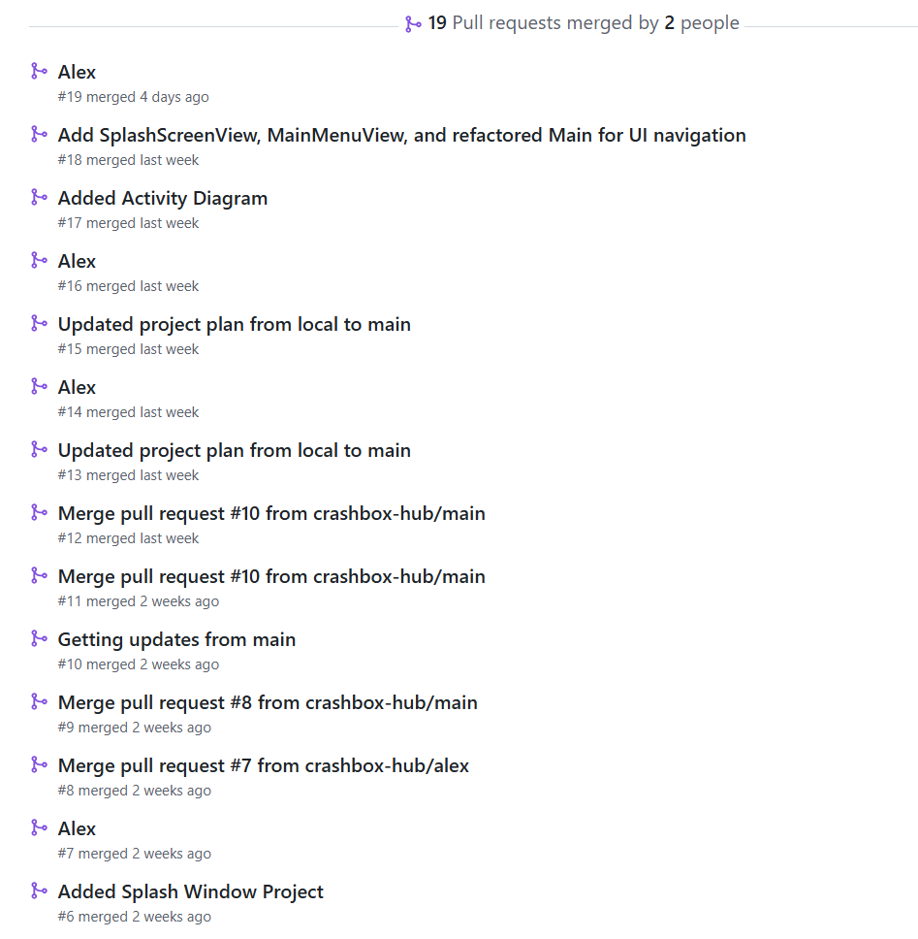
Figure 9. Project GitHub Pull Requests

Screenshot of code review:
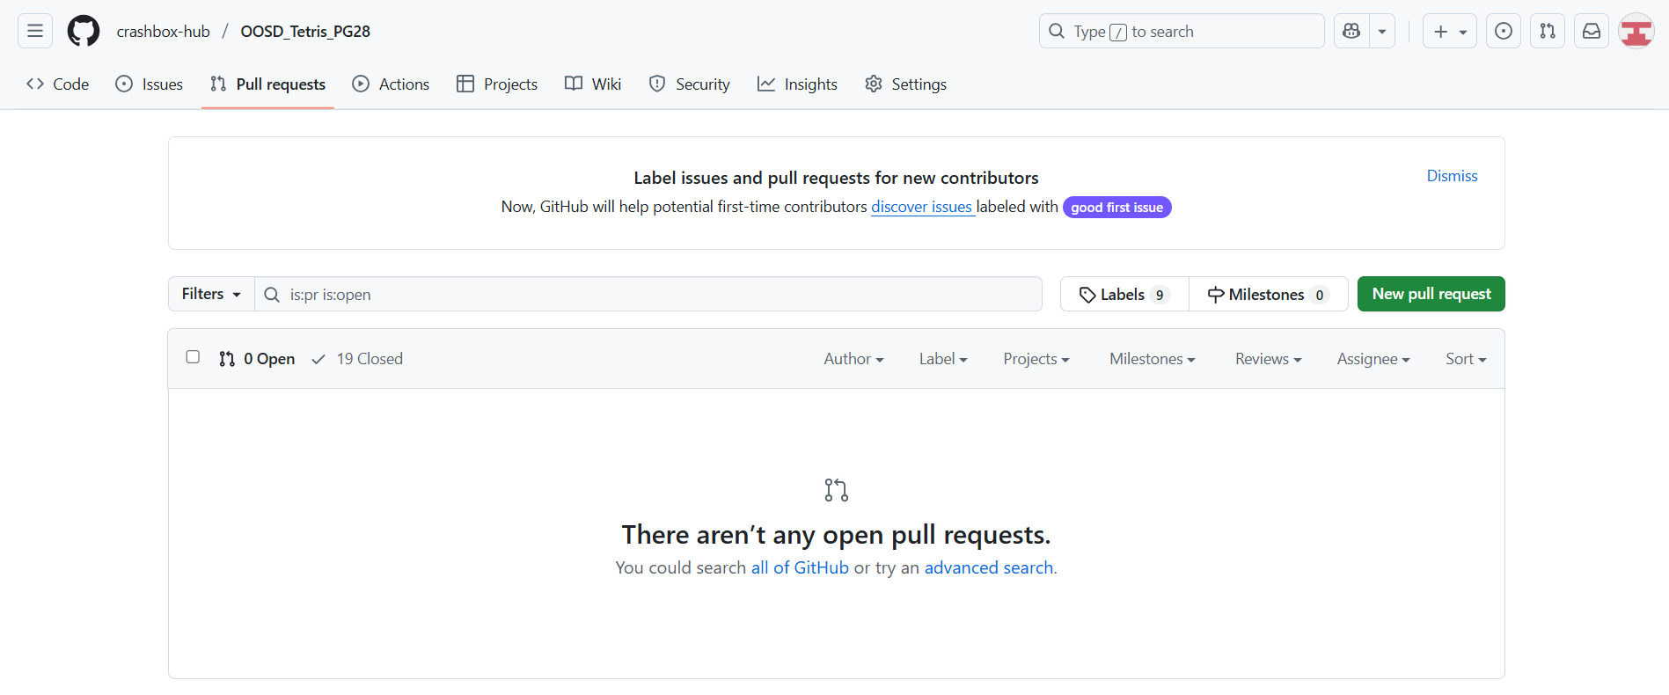
Figure 10. Code Reviews on GitHub

Screenshot of tags:
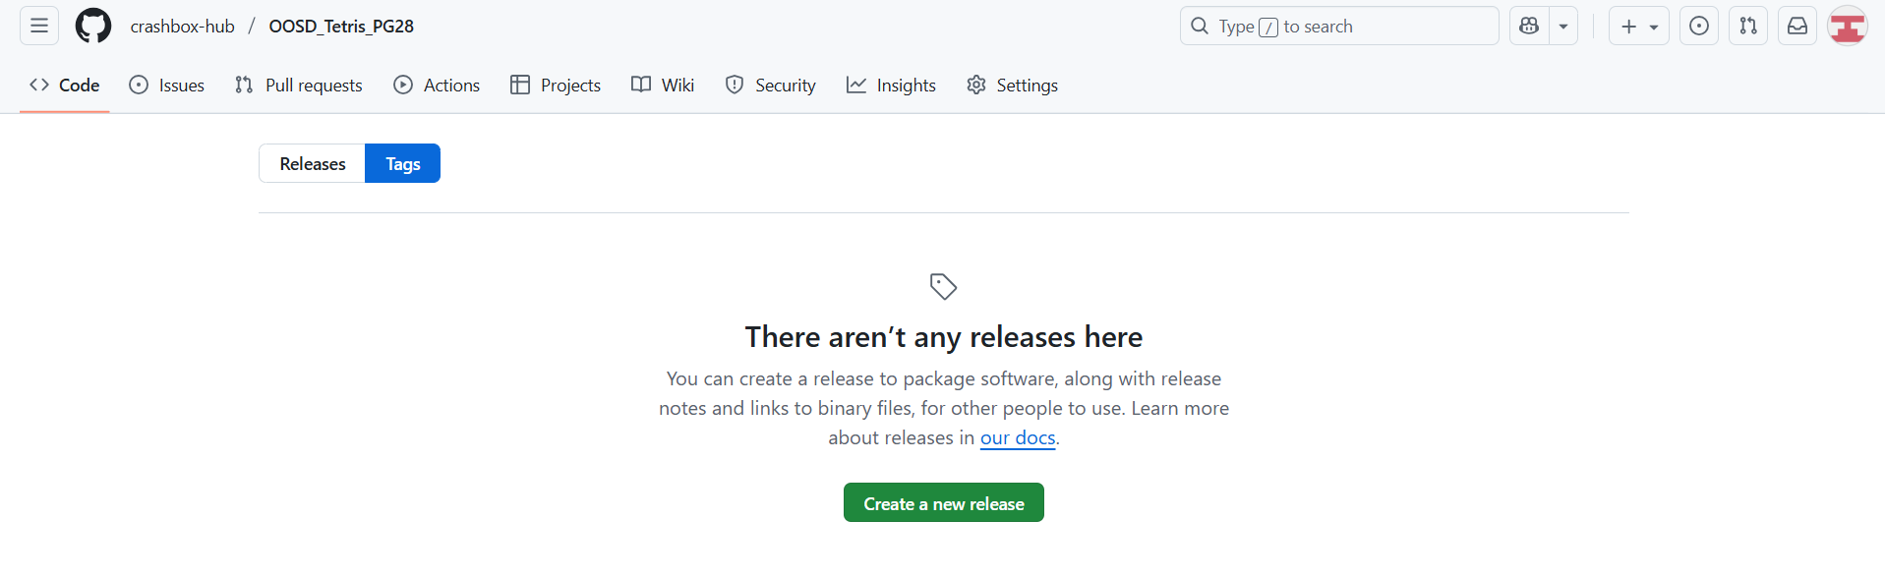
Figure 11. Tags used on Project GitHub Repo

File Structure
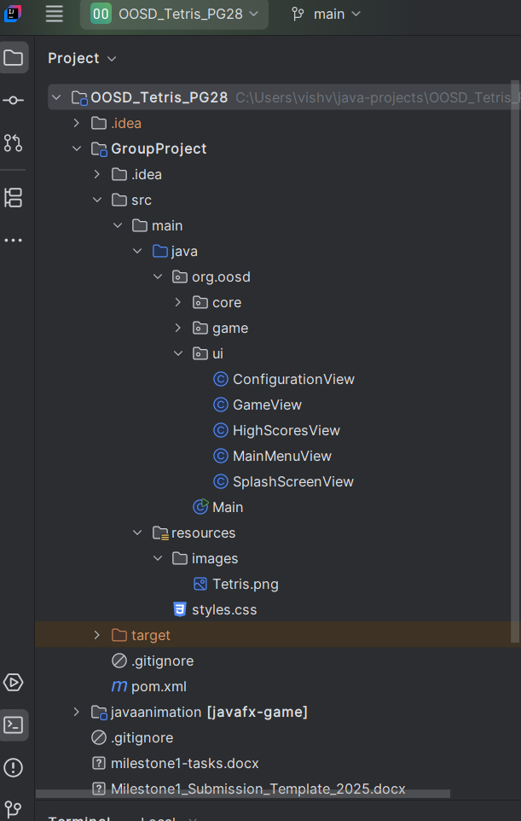
Figure 12. Project File Structure

Coding Snippets

JavaFX
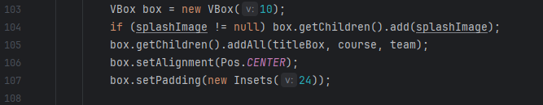
Figure 13. JavaFX Code from HighScoresView
Figure 13 illustrates JavaFX code with the VBox Layout Class. This arranges its children vertically, spacing them by the value of 10, given in the constructor. Next getChildren() from the code is the way that JavaFX manages nodes inside a layout container. The padding of the child nodes is then controlled by the Pos.CENTER, and Insets specifies padding inside the container.

Enhanced for loop
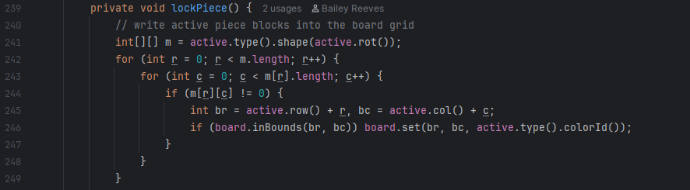
Figure 14. lockPiece Code from GameView Class

The goal of the lockPiece method, as seen in Figure 14, is to lock the active tetromino in place once it has landed. This requires getting the shape of the current piece and it’s rotation state (active.type().shape(active.rot())) , looping through every row (r) and column (c) of that 2D shape matrix, and writing each non-empty cell of the piece into the board at the correct position.
This is achieved with a nested for loop where the Outer Loop (r) Iterates through each row of the 2D array m. This allows us to move downwards through the tetromino's shape. The Inner Loop (c) Iterates through each column in the current row. This ensures that every single cell of the tetromino’s shape is checked. A conditional check
if (m[r][c] != 0) then filters out any “empty” cells, so that only the actual blocks of the tetromino are placed onto the board.
A position calculation adjusts the piece’s coordinates (r, c) to board coordinates
(br, bc), by adding the tetrominos active row and column. A boundary check is performed by board.inBounds(br, bc). This conditional logic provides a nested for loop that goes through the grid of the Tetris program to check if a piece has come to a stop or not.

Enhanced switch
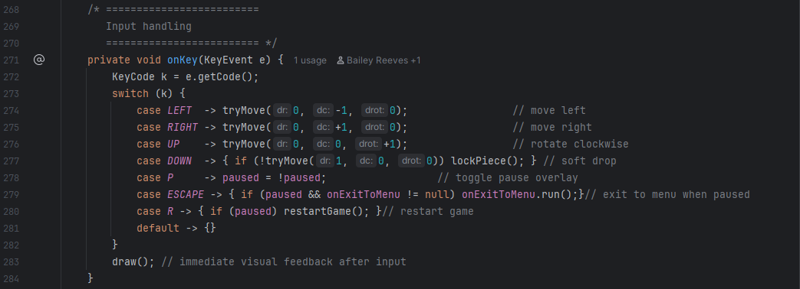
Figure 15. onKey Switch/Case from GameView Class

The onKey method in the GameView class is responsible for handling all player keyboard input and mapping it directly to in-game actions, as seen in Figure 15. It uses an enhanced switch expression to check which key was pressed and then immediately execute the corresponding logic. For example, pressing the left or right arrow keys calls tryMove to shift the active piece horizontally, while the up arrow key rotates it clockwise. The down arrow either soft-drops the piece (if possible) or locks it in place if movement is no longer possible. Other keys trigger global game controls. The P key toggles pause, ESC key exits to the menu when paused, and R restarts the game if the game is paused. After every input, draw() is called to refresh the screen, ensuring immediate visual feedback for the player.
This design is effective because the enhanced switch (case KEY ->) makes the code concise compared to traditional switch statements that require manual break statements. Each action is clearly tied to its key, making it obvious how input maps to gameplay. The inclusion of both simple single-line actions (moving left/right) and more complex block actions (soft drop or escape to menu) shows flexibility while maintaining readability.

Interface usage
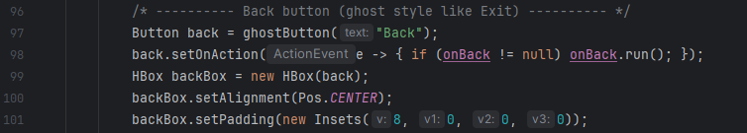
Figure 16. Example of Interface Usage from HighScoresView Class

The method seen in Figure 16, setOnAction in JavaFX expects EventHandler<ActionEvent>. This EventHandler is a functional interface as the button (back) listens for the user to click through the EventHandler<ActionEvent> interface. When the button is clicked the handle() method runs the code. This then checks if onBack exists, and if so it will call the run() method.

Abstract class usage
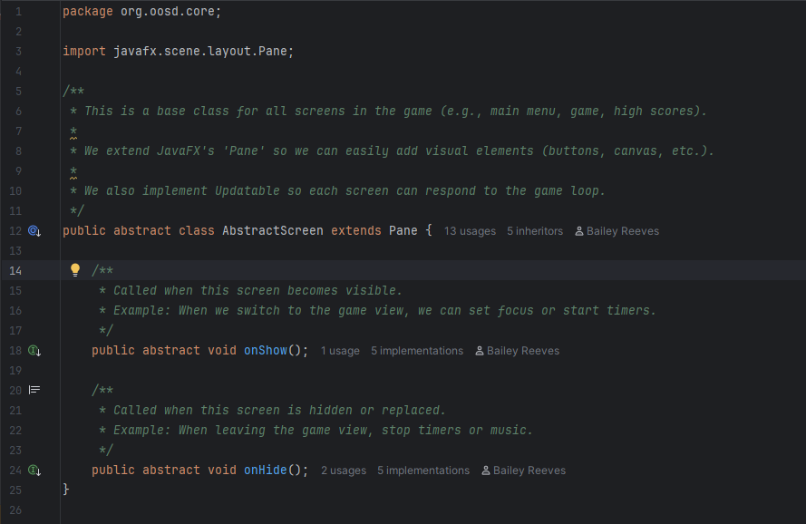
Figure 17. AbstractScreen Class Code

The AbstractScreen Class Code, as seen in Figure 17 & Figure 12 provides a blueprint for all the screens/views in the game (GameView, HighScoresView, MainMenuView, etc.). By extending Pane, it inherits everything from JavaFX’s Pane layout. With two defined abstract methods, public abstract void onShow(); and public abstract void onHide();
these methods have no body, just a promise that every subclass must implement them. The onShow() is called when athe screen becomes visible, and onHide() is called when switching away from a screen (timer stops, pause game etc.) and this enforces a consistent pattern across all screens.
Figure 18. Extension of AbstractScreen Class
Each screen in the UI extends AbstractScreen, as seen in Figure 18, while they are also able to define individual specific code, as they are required. This modular approach with JavaFX’s Pane ensures consistency.

Record type usage
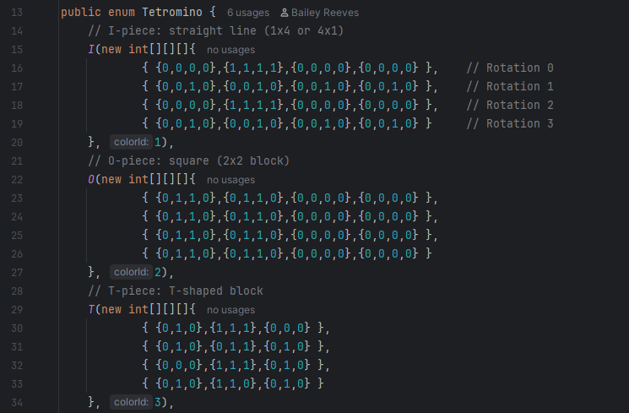
Figure 19. Public enum Tetromino Code

With the Tetris program the group defined a new type Tetromino, as seen in Figure 19. This public enum made seven “legal” values: I, O, T, S, Z, J, L. Instead of relying on strings or numbers this type was used to enforce type safety and readability.
Each of the seven tetromins has a rotation type int[][][] rotations (3D array storing all rotation states) and a colour type int colorId (an integer ID used by the UI to select a colour). By attaching these, the shape becomes bound to the type itself, with its rotational position, also removing the need for an external lookup table or if/else statement.

Part 4 - Demonstration

Demo Video Link
This video presentation, led by Vishva, demonstrates the overall functionality of our Tetris project. She will walk through each component of the system, beginning with the splash screen and main menu navigation, before moving into gameplay. The demonstration highlights features such as pausing, restarting, and exiting the game, as well as viewing the high scores screen, which currently displays sample data. Vishva also explains the configuration screen, which is included in the program but not yet functional. Finally, the video concludes by showing the exit process, which incorporates a confirmation pop-up to ensure a clear and user-friendly finish.

Video Link:
https://youtu.be/yJm5weYdWcI?si=EIavEsJH1k9XnDp6

